**System Requirements:**  The system is supposed to take jobs inputted by the user and execute them. There are two main modules, the scheduling module and the dispatching module. The scheduling module takes the jobs inputted from the user of the input and places them in a job queue. The dispatching module takes the jobs from the job queue and executes them. The Job submission module prompts the user to enter the job, priority, and execution time. The performance module tests and experiments to see the performance of the different scheduling algorithms.

**Diagrams:**

Data Flow

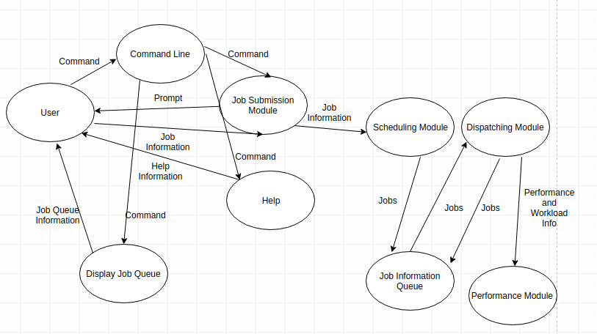

Structure Diagram

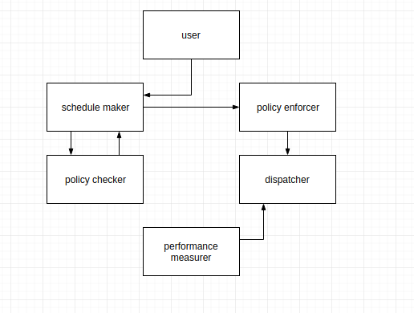

**Tests:**

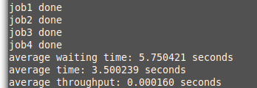

**Development Model: Agile Development Model**

Implementation and development stage: The requirements for the system were defined, and the data flow and structure diagrams were successfully created. We then went on to create the the scheduling and dispatcher thread for the system. After successfully creating the threads, we implementing the scheduling module to put hard coded jobs into a queue. Then we implemented the dispatching module to take those jobs and execute them. After successfully getting the hard coded jobs to execute, we created the user interface and implemented it with the scheduling module. Then we implemented the priority and shorted job first scheduling algorithms in the scheduling module.

Testing Stage: We created a make file to separately compile and test our system. We then tested the performance of our system with test cases.